

**UNIVERSITY OF PETROLEUM AND ENERGY STUDIES**

**School of Computer** **Science**

**2020 - 21**

**Graphics and Animation Tools Lab**

**Faculty: Dr. DURGANSH SHARMA**

**Assistant Professor**

**Department of Cybernetics.**

**School of Computer Science, UPES**

Submitted By:

Name - Vartika Deep

Sap Id - 500062441

Course - B.Tech CSE(OS&OS)

Semester - 7

Batch - B3

Roll no. - R100217088

**Experiment - 7**

**Design 3D Rocket using Blender**.

**Steps:**

1.Add UV Sphere and increase the rings in it.

2.Scale the object along z-axis.

3.Delete the bottom faces of the object.

4.Go to bottom of the object and select two opposite faces and scale them.

5.Add Ico sphere at the bottom of the object.

6.Go to Object – Quick Effects – Quick Smoke.Set Smoke Style to Smoke+Fire.

7.Rotate the smoke domain to make the flow of the fire downwards.

8.Select all the object and tilt them towards right.

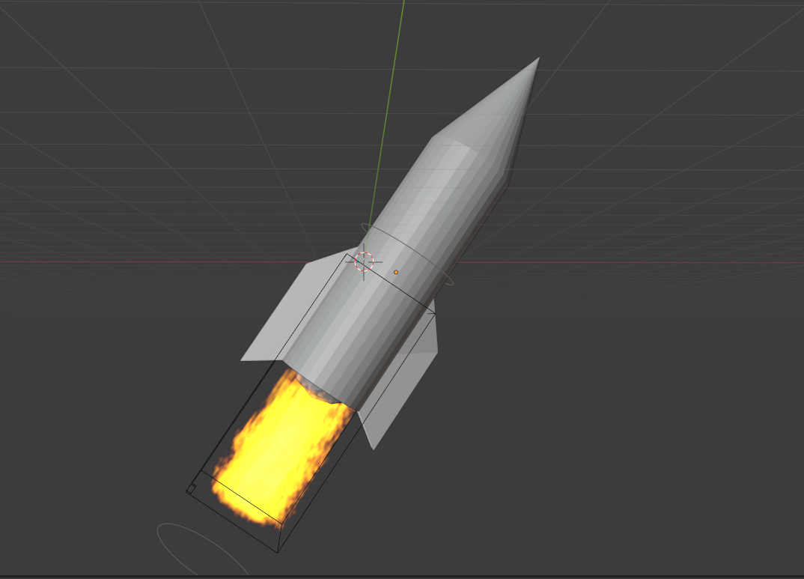

Link:

https://drive.google.com/file/d/1ndTLQsa0qwlYBKLLR1sPa026kQxoezpM/view?usp=sharing